Third Grade News Letter From Sister Noel’s Classroom (10/22-26 )
sr.noel@sjb-school.org
This week we will be learning:  Language Arts  (continue lesson 6)  New  - reading an informational text.  Key skill  Graphic Features  Grammar & Writing  - verb tenses – present, past & future  - compare and contrast paragraph  - concrete poem  Handwriting: cursive lowercase letters | Bible Verse for the week  God is with you in everything you do. ( Genesis 21:22)  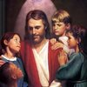  Dates to Remember  Oct. 22 - Rosary Grade 3, 3:00 PM  Oct. 30- Book it Reader Form due  Oct. 31 – All Saints Party 2: 30 and 6:00 – 8:00  Nov.01 - All Saints Day (Holy Day)  Nov.02 - All Souls Day, Grandparents’ Day , Mass at 11:00  BOOK IT:  Required goal for “Book It” Oct. 250 minutes of reading, Super Readers -500+minutes of reading | Vocabulary &Spelling: Lesson 7  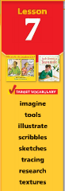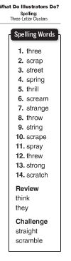  Reminders:  Read -“What do Illustrators Do?” P. 222 - 242  Extra credit - Text P. 246 - 249  Spelling test on Monday, Oct. 29  Math – practice on Khan Academy (use Google Account) lastname.firstname@sjb-school.org , use student’s own password
Math
- estimate sums and difference
- add and subtract 3 - 5 digit numbers
- count bills and coins
- compare money amounts

Science
Plant Life Cycle
Weekly Reader
Social Studies
Our Country’s Geography
Map and Globe skills
Compare and contrast facts about 2 communities
Due: Nov. 2nd
Religion
- understand that Jesus’ power to forgive and heal comes from God ( (Lesson 5)
- study Scripture Verses
- work with Saints’ project
- Saint of the Month – St. Thomas Aquinas

