Third Grade News from Sr. Noel’s Class (Sept. 17 - 21 , 2018 )
sr.noel@sjb-school.org, http://grade3-sjbschool.weebly.com
Language Arts  This week we will be reading a realistic fiction.  - draw conclusions based on story details.  - understanding characters  - long a and long e spelling words  Grammar & Writing  - kinds of sentences  - antonyms  - sentence fragments and run-on sentence  - personal narrative paragraph | Bible Verse for the week  Faith is the realization of what is hoped for and evidence of things not seen. (Hebrew 11:1)  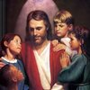  Upcoming Events  Sept. 19, 24 and 27 - NWEA testing days  Sept. 30 - Parish Festival  Oct. 03 - Field trip to Heritage Village  (10:00 - 3:00)  Phys Ed : Tuesdays and Thursdays  Music : Mondays and Wednesdays  Fall Festival – We need a parent volunteer to put together a basket for silent auction | Vocabulary & Spelling : Lesson 3  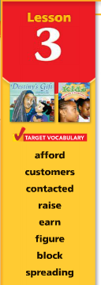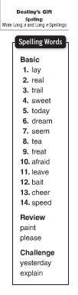  Reminders:  Work with Vocabulary Words  Read the story “ Destiny’s Gift” P. 74 - 101  Challenge activity (extra credit) Text p. 105  Spelling test - Monday Sept. 24
Math
This week we will
- learn place value 5 and 6 digit numbers
- create number patterns

Science
Living things and their needs
Weekly Reader
Social Studies
Unit 1 - Communities Around Us
Communities are different
What is a Community?
Map and Globe skills

Religion
Unit 1: The Church is One : Focus on the Sacraments of Christian Initiation
Students will learn
- Scripture Verses, Virtue - Hope
Saint of the Month – St. Elizabeth Ann Seton
Each student will pick a saint to study about the life of the saint

