Third Grade News from Sr. Noel’s Class ( 3 / 25 – 29)
sr.noel@sjb-school.org, http://grade3-sjbschool.weebly.com
This week we will  Language Arts  - read an informational text, “The Journey :  Stories of Migration”  - compare and contrast  Grammar & Writing  - using proper nouns and possessive pronouns  - write to express – descriptive paragraph  - using similes  - writing narrative poems | BIBLE VERSE FOR THE WEEK  “Let anyone who thirsts come to me and drink.”  John 7:37  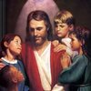  Dates to Remember  Mar. 25 - Stations of the Cross (Gr.3)  Mar. 27 -JA- Class # 4 at 2:35  Mar. 28 -Scholastic Book order due  April 1 – BOOK IT Reader form due  April 07 – Bingo Fun Day ( students please volunteer to help with games)  April 10- Class Mass | Vocabulary &Spelling: Lesson 22  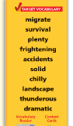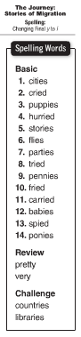  Spelling test - Monday April 1St  Assignments:  Reading : Unit 5 – “Going Places”  Read: Text pages – 170 - 191  Extra credits text p. 192 - 195
Math
Unit 8: Understand Fractions
- identify, read, and write fractions as parts of a whole
- study multiplication facts 1-12
- multiply and divide 2 digit numbers by 1digit
Science
Physical Science – Forces and Energy
-describe and relate position and motion
-define speed using distance and time
Social Studies
State and National Governments
Symbols of our Nation
Governments of the World (P.280 – 307)
Religion
Lesson 13 – The Church Continues the Mission of the Apostles
identify traditions passed on by parents
-study scripture verses
- pray the Stations of the Cross - Lent

