Third Grade News from Sr. Noel’s Class (Sept. 10 -14, 2018 )
sr.noel@sjb-school.org, http://grade3-sjbschool.weebly.com
Language Arts  This week we will be reading another Humorous fiction.  The students will  - learn to draw conclusions based on story details.  - study multiple meaning words, compound words  Grammar & Writing  - proper nouns  - different kinds of sentences  - write to narrate (Friendly Letter) | Bible Verse for the week  The Lord is My shepherd; there is nothing I lack. (Psalm 23:1)  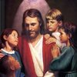  Upcoming Events  Sept.17- Pizza Lunch  Sept.12 - Third Grade Class Mass  Sept.21 – Hot Lunch  Sept.30 - Parish Festival  Oct. 03 - Field trip to Heritage Village, need volunteer drivers  Fall Festival – need a parent volunteer to put together a basket for silent auction | Spelling & Vocabulary: Lesson 2  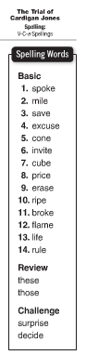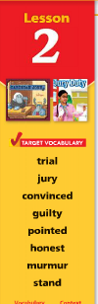  Reminders:  Read Leveled Book Lesson 2 on Think Central (in class)  Work with spelling & vocabulary words (in class and at home)  Write sentences using vocabulary words and illustrate 2 words  Read the story “ The Trial of Cardigan Jones” text page 42– 65  Challenge activity is in Text p. 69 (at home)  Spelling test on Monday Sept. 17  School spirit – Monday – Thursday  PE-Tuesdays & Thursdays  Music- Mondays & Wednesdays  Snack- 10:20  Fr. Cole’s Visit – every other Wednesdays
Math
This week we will
- identify even and odd numbers
- learn place value 3- 4 digit numbers
- describe, create, and predict number patterns
Science
Living things and their needs
- identify the steps in the scientific method
Weekly Reader – Koala Care

Social Studies
Introduction: Five themes of Geography Communities Around Us
Map and Globe skills

Religion
Unit 1: The Church is One
Lesson 1: The Holy Spirit Guides Us to Live as Christians
Students will learn
- Scripture Verses

