Third Grade News from Sr. Noel’s Class (2/ 25 -28)
sr.noel@sjb-school.org, http://grade3-sjbschool.weebly.com
Language Arts  This week we will  -read a fantasy story Dogzilla  -use cause-effect relationships to summarize  Skills:  -identify the characters  Spelling, Grammar & Writing  -irregular verbs  -write to persuade – persuasive letter/ opinion | BIBLE VERSE FOR THE WEEK  “The Son of Man did not come to be served but to serve and to give his life as a ransom for many.” (Mt. 20:28)  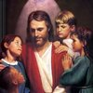  Dates to Remember  Feb. 27 – J.A.  Feb. 27 & 28 - parent/Teacher Conference  Mar.01 - “Book It” Reader form due  March – Ash Wednesday  Mar.08- Science Fair | Vocabulary &Spelling: Lesson 19  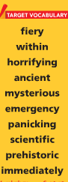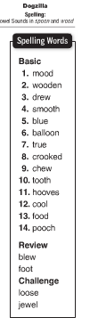  Spelling test lesson 19 will be on March 4th (not on the 25th)  Assignments:  Work with Spelling and Vocabulary words  Read text p. 104 – 127 (Home)  Extra Credits P. 128 – 131 (Home activity)
Math

Chapter 17 – Customary Units: length, weight,, capacity and temperature

Science
Engineering: Designing Parachutes
Earth, Sun, Moon and Planets Unit (continue)

Social Studies
Our Country’s History
-compare and contrast Native American tribes
-describe the culture, housing, economy and other ways of life of Native Americans

Religion
Chapter 11-identify the qualities of a good messenger
-explore the meaning of grace

