Third Grade News from Sister Noel’s Class (Jan. 7-11, 2019
Sr.noel@sjb-school.org , http://grade3-sjbschool.weebly.com
This week we will be learning:  Language Arts  - reading an informational text “ Aero and officer Mike” (Continue)  Key skill  -author’s purpose  Spelling, Grammar & Writing  - contractions  - vowel + r sounds  - pronouns and verbs  - write to narrate ( autobiography)  -forming the past tense | BIBLE VERSE FOR THE WEEK  I came into the world as light, so that everyone who believes in me might not remain in darkness. (John 12:46)  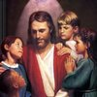  Dates to Remember  Jan. 10- Picturing America  Jan. 11- Library  Jan.14 - Science Test Ch. 8 (P. 314 – 355)  Jan. 25 - Library  Jan. 27 - Catholic Schools Week – All School Mass  Thank you parents for organizing a Super Christmas party for our students Gr.1-4. And also thank you for the generous gifts you gave me for Christmas!  It is about half of the school year is over. Because we are working hard in 3rd grade, some of our supplies are about to gone. A box of regular wooden pencils (12-24) and it may also good for your child to have a good, working, hand pencil sharpener in the supply box. | Vocabulary &Spelling: Lessons 15  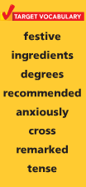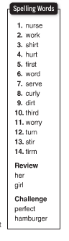  Assignments:  Jan. 14 – spelling/vocabulary work due  Jan. 14 - Spelling test (Lesson 15)  Read: “The Extra –Good Sunday from Ramona Quimby, Age 8” Lesson 15 ( P. 486 -508 )  Extra credit: Reading Text p. 513
Math
- connect addition/ multiplication, division/ subtraction
- geometry
- study multiplication facts 1-10
Science
Planets, Moons, and Stars
Lego Robotic Lessons – build, program, run, and present
Social Studies
Our Country’s History (p. 155 -187)
Map and Globe skills
Religion
-understand that scripture reveals that Jesus offers living water ( Lesson 9)
Church Year – The Season of Incarnation
Virtue of the month: Fidelity - Being faithful to promises and commitments
Saint: Bls. Luigi & Maria Quattrocchi

