Third Grade News From Sister Noel’s Class ( Dec.3 –7)
Sr.noel@sjb-school.org , http://grade3-sjbschool.weebly.com
This week we will be learning:  Language Arts  Unit 3: Learning Lessons  Lesson 11- “Jump” (continue)  Lesson 12- “The Science Fair”  Key skills  - distinguish facts from opinion  - story structure  - learn homophones, plurals of irregular nouns and more Proper Nouns  Writing  - plan a descriptive paragraph  - write a poem  Handwriting: cursive letters | BIBLE VERSE FOR THE WEEK  Ask and you will receive; seek and you will find; knock and the door will be opened to you. (Luke 11:9)  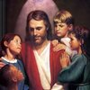  Dates to Remember  Dec. 3- Advent Prayer at 3:00  Dec. 8– Feast of the Immaculate Conception of Blessed Virgin Mary  Dec. 21- Advent Prayer Service at  9 : 00 am, Gr.1 and 3 are leading  Jan. 3 – Class Mass  BOOK IT:  Required Reading goal for December is 250 minutes and Super Readers 500 + minutes, verification form due on Jan. 3rd  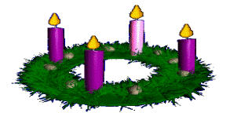Have a Blessed Advent! | 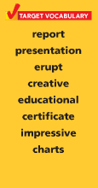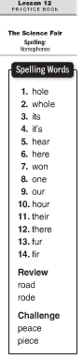  Spelling test # 12, Dec.10  Assignments:  Read -“Jump” P. 366 – 388 and Lesson 12 p. 399 – 417  Extra Credit text p. 418 - 421
Math
- connect addition and multiplication
- multiply with 3,4, and 10

Science
Living things in Ecosystems (continue)
Planets, Moon, and Stars
Lesson 1- The Sun and Earth

Social Studies
Communities Over Time (Text p. 145 -232)
Map and Globe skills

Religion

Lesson 8: We pray to the Holy Spirit
-prepare for the Sacrament of Reconciliation
-Church Year – the Season of Advent

