Third Grade News From Sister Noel’s Class (Nov. 12-20)
sr.noel@sjb-school.org, http://grade3-sjbschool.weebly.com
This week we will be learning:  Language Arts  -reading a biography lesson “Young Thomas Edison”  Key skills  -main ideas &details; summarize  Grammar & Writing  - pronouns  - concrete poem/story  Handwriting: cursive letters | Give thanks to the Lord, for he is good; his love endures forever. (Psalm 118:1)  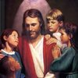  Dates to Remember  Nov.16 – Saints’ Dress up Presentation, all are welcome to the 3rd grade room at 2: 45  Nov. 19 - Field trip to VPM, bring $5.00 or less to buy appropriate items, hands on activity using money  Nov. 28 – Class Mass, show & Tell  Nov.30 – “Book It” form due  Nov.30 – Library  BOOK IT:  Required Reading goal for November is 250 minutes. For Super Reader Award read 500+ minutes. | Vocabulary &Spelling: Lesson 10  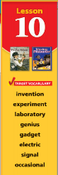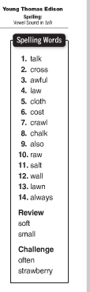  Spelling test # 10 on Monday, Nov. 19  Assignments:  Read -“Young Thomas Edison” P. 322 - 349  Extra credit - Text P. 350 – 353  Nov. 20 - Math Unit 2 test (Lessons 4-7) Math: study guide text P. 150 & 151  Have a Happy Thanksgiving!
Math
Chapter 7 – Understand Time
- tell time A.M. and P.M.
- elapsed time, time line
- unit review and test
- connect addition and multiplication
- multiply with 2, 3 & 5
Science
Living things in Ecosystems
Weekly Reader
Social Studies
Communities and Geography
Map and Globe skills
Chapter 3 test (p. 73 -111)
Religion
-explore the meaning of the Great Commandment
-understand that Jesus teaches the Good news with authority of God ( Chapter 7)
- study Scripture Verses
- saint of the week – Louise de Marillac
- saint of the month – Padre Pio
-virtue - humility

