`
Third Grade News from Sr. Noel’s Class (May1 –6 )
sr.noel@sjb-school.org, http://grade3-sjbschool.weebly.com
Language Arts  The power of the Magnets  This week we will  -use the cause and effect, sequence of events  Grammar & Writing  - writing quotations  - write to inform  - compare and contrast poems | Bible Verse for the Week  “He Gives Me Peace.” ( John 14:27)  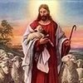  Dates to Remember  April 30 – NWEA test Language 10:30 -11:45  April 30 – Reading Adventure Kick-off at 3:00  May 1- NWEA test Reading 10:30 – 11:45  May 2- Fr. Cole Visits classroom  May 3- All school Field trip  May 4- No school  May 7- NWEA test Math 10:30 – 11:45  May 8 -Permission form and Money due for Sea-Life MN  May 9- Reading Adventure group at 10:15  May 21- Rosary 3rd grade leads 3:00-3:20  May 23-Class Mass  May 23- Class Field trip to Sea – Life MN 10:30 -3:00  Picturing America, Library – last day to check out books ? | Spelling & Vocabulary: Lesson 27  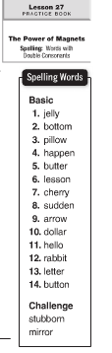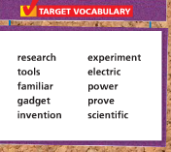  May 8 - Spelling Test Lesson 27  Assignments and homework:  Read Book : “Make Your Mark” P. 20 -33  Math: practice on iXL  Write spelling words 2X in cursive and work with Vocabulary
Math
This week we will
-review math skills
Science
Adaptations:
-recognize organisms that survive in certain environments, animals and plants that live in the ocean
-research work on water habitats
Social Studies
Citizens and Government ( 270 -
- focus on Constitutional principles, local and national governments
Religion

Lesson 16 - We Pray for Faith ”
We will
- understand that the beliefs of the Catholic Church are in the Apostles’ Creed
- explore the meaning of the of the Apostles’ Creed
- pray the Apostles’ Creed

