`
Third Grade News from Sr. Noel’s Class (April 23 – 27 )
sr.noel@sjb-school.org, http://grade3-sjbschool.weebly.com
Language Arts  This week we will  Long Articles: The Foot Race Across America  Target Skill: Main ideas and supporting details  Grammar & Writing  -use quotation marks with a person’s exact words  -write to inform | Bible Verse for the Week  He sent them to proclaim the kingdom of God. (Luke 9:2)  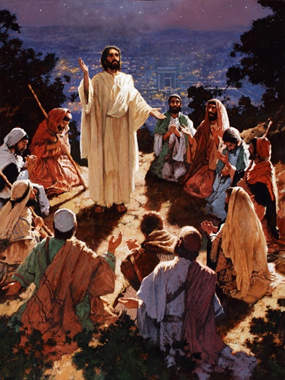  Dates to Remember  April 24 – sending the field trip parent consent form  May 1- 30- Reading Adventure  May 23 – Class Field Trip to “Sea –Life” 10:30 – 3:00  May 23 – Class Mass  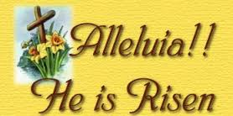 | Vocabulary: Lessons 26 & 27  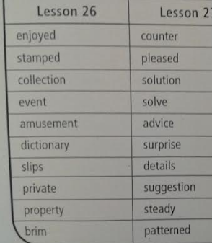  Spelling: Leson 26  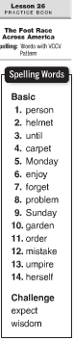  April 30 - spelling test # 26  Spelling words write 2 X in cursive  Assignments:  Reading : Unit 5 test  Unit 6: Reading Adventures - Lesson 26 &27  Read Magazine P. 4 -17, A Folktale from Brazil (in class)
Math
Fractions and Decimals Review (Text P.514-595
Study Multiplication
Science
Electrical and Natural Gas Safety
Adaptations:
-recognize organisms that survive in certain environments, animals and plants that live in the ocean
-research work on water habitats
Social Studies
Citizens and Government
-understand and apply some rights of citizens
Duties of Citizens (P. 248 – 256)
Religion

